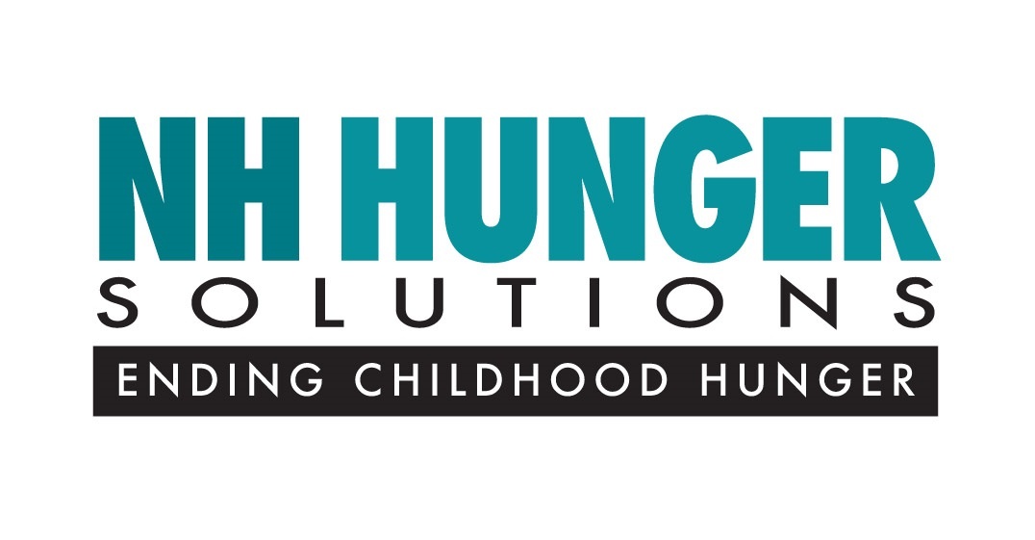

Tuesday, February 14, 2017 12:01 AM

Contact: Amy Bourgault
office: (603) 225-2264
e-mail: amy@nhhungersolutions.com

New Hampshire Ranks 50th in School Breakfast Participation

Concord, NH — New Hampshire ranks second-to-last place in the nation for school breakfast participation according to the annual School Breakfast Scorecard Report released today by the Food Research & Action Center (FRAC).

The new FRAC Report highlights federal, state and local strategies for increasing participation in the national U.S. Department of Agriculture [USDA] School Breakfast Program. The Report also measures the reach of the School Breakfast Program in the 2015–2016 school year, in each state, based on a variety of metrics and impact. The National School Breakfast Program makes it possible for all school children to receive a nutritious breakfast in school.

The Report is accompanied by a Scorecard that finds 15,991 children in New Hampshire participated in school breakfast on an average school day in 2015-2016, a 2.3 percent increase over the previous year. In the same year, the number of students in the state who participated in the National School Free and Reduced Price (NSLP) Lunch Program is 40,367.

The Report also focuses on the ratio of school breakfast offered versus national lunch participation for low-income families. In New Hampshire, there is a ratio of 41 school breakfast participating children for every 100 free and reduced-price lunch participants. New Hampshire is below the national average of 56 breakfast for every 100 free and reduced-price lunch.

According to FRAC, if New Hampshire met the goal of reaching 70 low-income children with school breakfast for every 100 participating in school lunch, New Hampshire would be eligible to receive an additional $3.1 million in federal funding.

New Hampshire’s low participation in school breakfast ranking can be attributed in part to the lack of widespread implementation of alternative service models such as “grab and go,” “second chance breakfast,” and the “Community Eligibility Provision,” which provides free meals to all students in schools with a high ratio of free and reduced priced lunch participants.

“Having a healthy school breakfast enables more children to start their day with the nutrition they need to learn.” said Amy Bourgault, of New Hampshire Hunger Solutions. “Students who regularly start the day with breakfast are more likely to miss fewer school days, have better concentration in school and overall better health.”

# # #

New Hampshire Hunger Solutions is a statewide, research based, advocacy organization that is working to alleviate childhood hunger in New Hampshire through long-term solutions.

FRAC is a national anti-hunger advocacy group that analyzes certain programs aimed at curbing food insecurity among children nationwide (www.frac.org).

The new FRAC School Breakfast Report and Scorecard is available on NH Hunger Solution’s website: http://nhhungersolutions.com/reports.

Information on the USDA School Breakfast Program is available on the website: https://www.fns.usda.gov/sbp/school-breakfast-program-sbp

